1. Let’s download Docke.  
   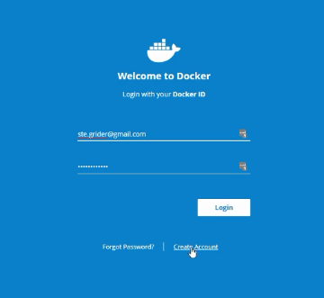  
   Create account as we’re going to do a lot of things with Docker inside this course.
2. 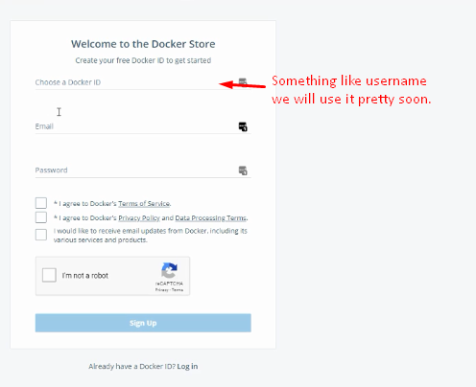 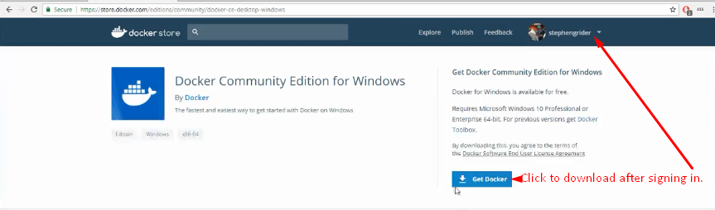
3. 